Silver - Bits to numbers

Problem 1 It’s all bits to me
Convert each binary number into a decimal number.
- Multiply each binary digit with its multiplier.
(There’s space below the digits to keep track of which multipliers to include.)
- Add up the products to work out the decimal number.
Here is an example:
Binary number |  |  |  |  | ▹ | Decimal number
16 | 8 | 4 | 2 | 1
1 | 1 | 0 | 1 | 0 |  | 26
16 | 8 |  | 2 |  |  | 16+8+2

Now, try these on your own:
Binary numbers |  |  |  |  | ▹ | Decimal numbers
16 | 8 | 4 | 2 | 1
 |  |  | 1 | 0
 |  | 1 | 1 | 0
 | 1 | 0 | 1 | 1
1 | 0 | 0 | 1 | 0

Problem 2 Birthday bits
You have a friend who loves binary numbers. You ask her when her birthday is, and she writes the following on a piece of paper:
11001
1100
Then, you ask her how old she is, and she draws a birthday cake with binary candles!
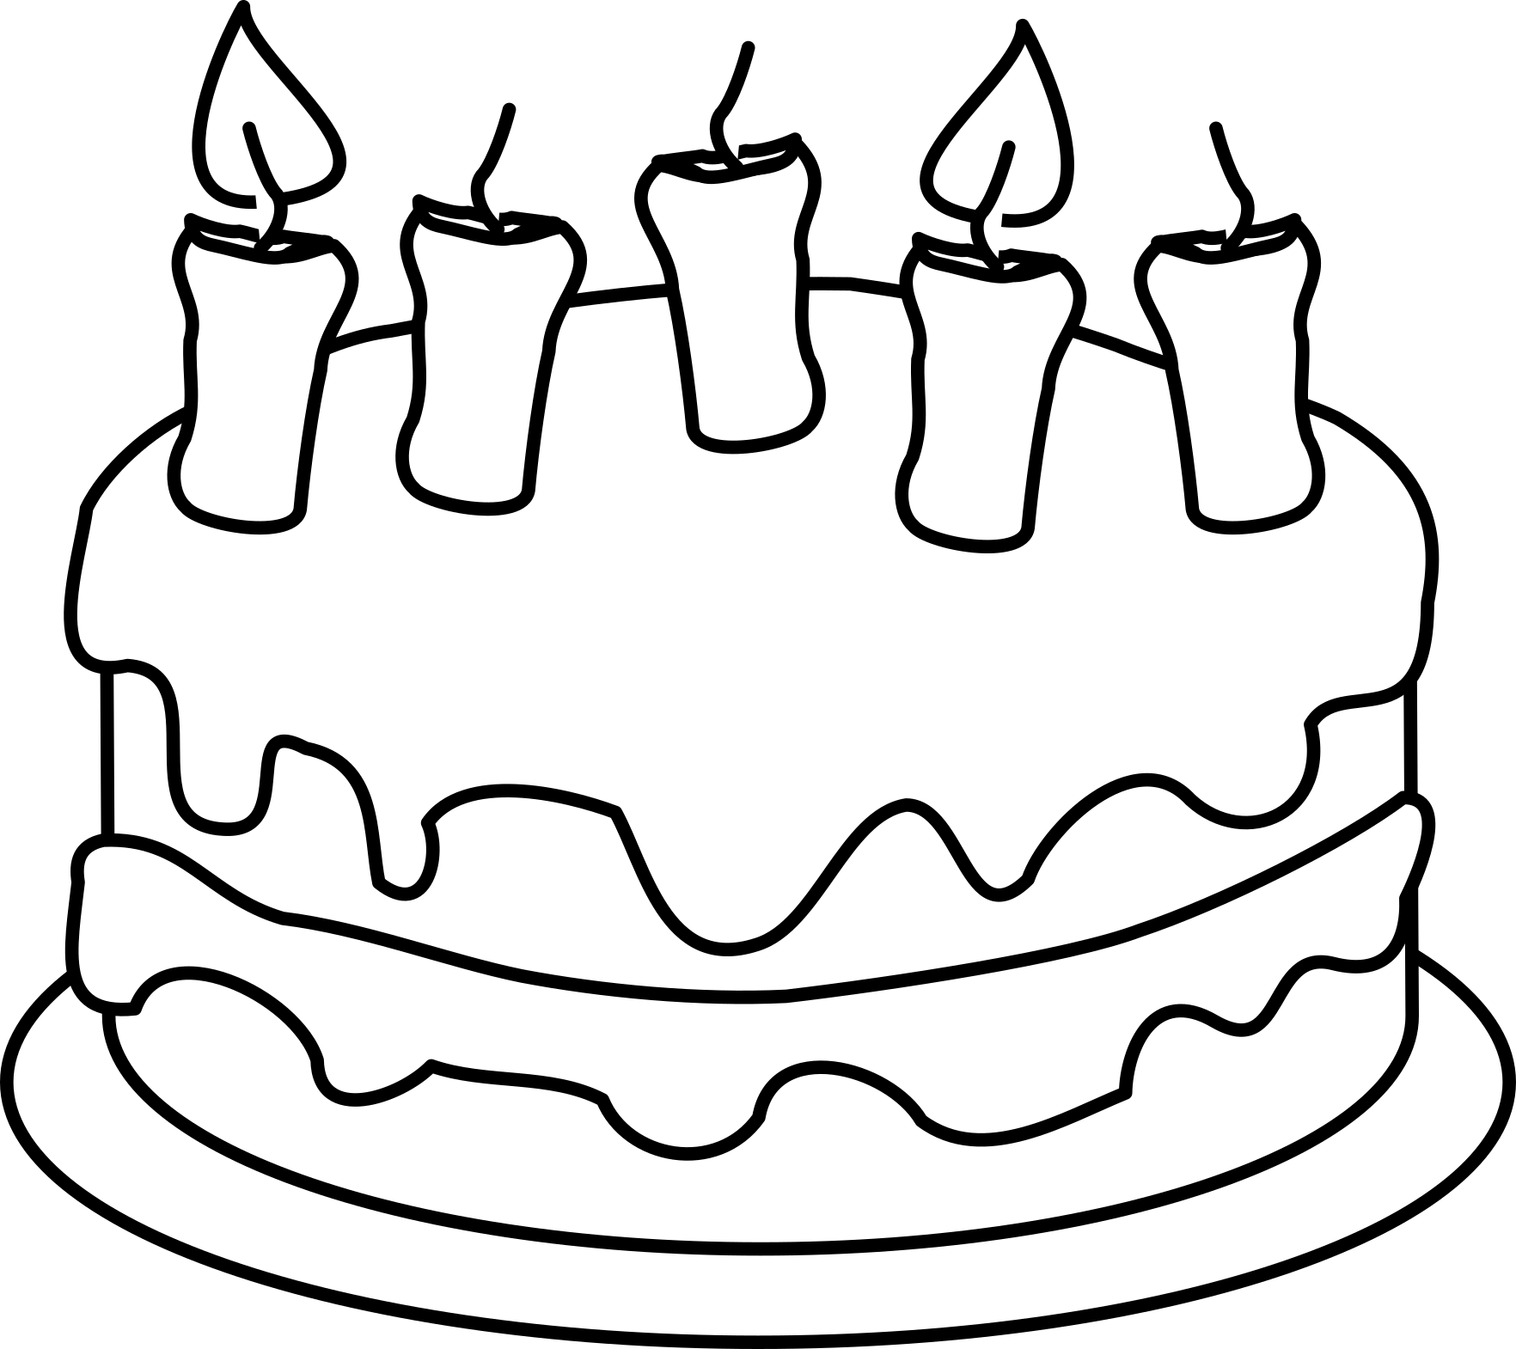
cake image derived from Tux Paint birthday cake.svg [CC BY-SA 3.0]
Questions | Your answer
When is your friend’s birthday?

How old is she?
Hint: Think of the candles as binary digits.

Explorer task .
If you have finished these problems and there is still time remaining, ask your teacher to assign an explorer task to you.

