Turing’s mug
Alan Turing is widely considered to be the ‘father of computing’.
During World War II, his secret work at Bletchley Park was central to decrypting German communications.
Turing was an eccentric man. In his wartime office, he would lock his mug to the radiator with a combination lock. No one knew the combination, so that mug is still there...

Your mission .
The National Museum of Computing has uncovered a clue that may help unlock the mug. They have asked for your help. They let you in to Turing’s office and show you the clue.

The pattern .
There is a pattern of white and black circles in one of Turing’s notebooks.
You suspect that these are binary numbers, so you try converting them to decimal numbers.
You also check if the numbers could correspond to letters. Cryptanalysts should try everything!
 |  |  |  |  | Decimal | Letter
◯ | ◯ | ⬤ | ◯ | ⬤
◯ | ⬤ | ⬤ | ⬤ | ◯
◯ | ⬤ | ◯ | ◯ | ⬤
◯ | ◯ | ⬤ | ⬤ | ⬤
◯ | ⬤ | ⬤ | ◯ | ⬤
◯ | ◯ | ◯ | ◯ | ⬤

The list of words .
Interestingly, the letters form a word.
You flip through Turing’s notebook, trying to find it. On the last page, you find a list, and the word is among them! You are on the right track. But what are the three numbers next to the word?
bicycle 109 7 111
babbage 79 102 7
enigma 6 79 111
runner 125 127 0
cipher 0 91 109
machine 91 125 111
chess 127 109 7

The display .
That’s when you notice the strange display on the desk:
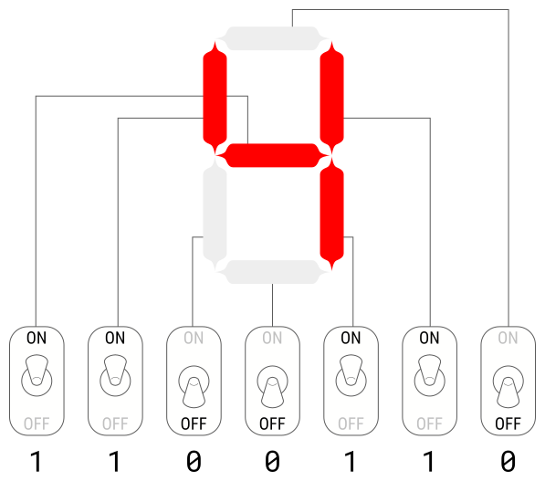
Now, you realise what you have to do:
- Convert the three numbers next to the word to binary.
- For each number, set the switches according to the binary numbers and colour the corresponding segments. Check the digits that appear on the display.

The combination .
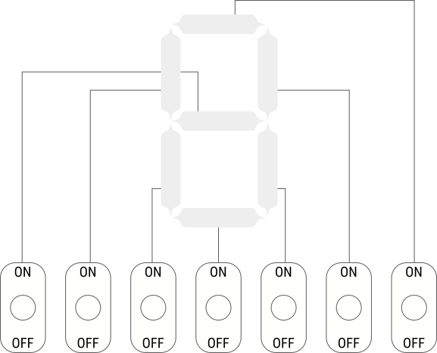

This resource is licensed under the Open Government Licence, version 3. For more information on this licence, see ncce.io/ogl.

