Spreadsheet: decimal to binary
Follow these steps to create a spreadsheet that converts decimal numbers into binary.
You need to be familiar with simple formulas (calculating the difference and product of two values), the IF function (determining the value of a cell depending on a condition), and the AutoFill feature.

Step 1 The decimal number.
Designate a cell where the decimal number will be entered and an area (a group of cells) where the corresponding digits of the binary number will be computed.
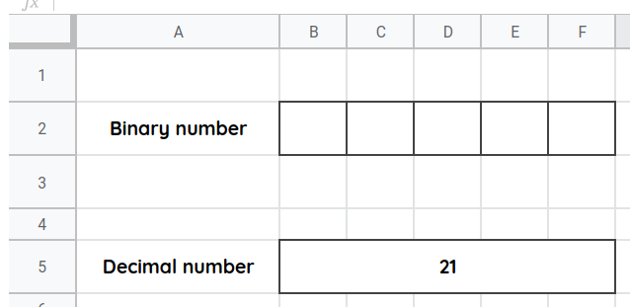

Step 2 Multipliers
Compute the multiplier for each of the binary digits. Use the cells above the binary digits.
Note: Do not enter the multipliers by hand, except the multiplier of the rightmost digit (which equals 1). Every other multiplier should be twice as big as the one to its right.
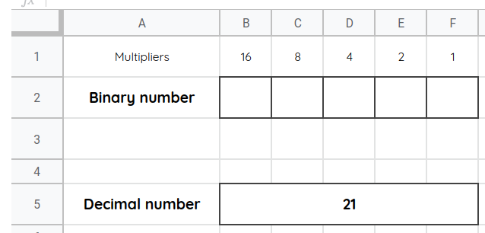

Step 3 Remaining values
Use the cells below the binary digits to store the values that remain to be represented. At first, make sure that the remaining value under the leftmost binary digit equals the initial decimal number.
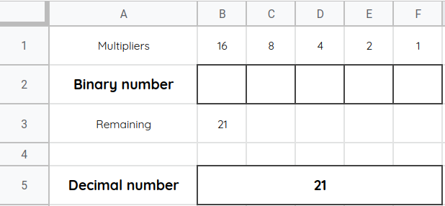

Step 4 The first binary digit
Compute the first binary digit.
If the value that remains to be represented (under the binary digit) is smaller than the multiplier (above the binary digit), then the binary digit should be set to 0. Otherwise, it should be set to 1.
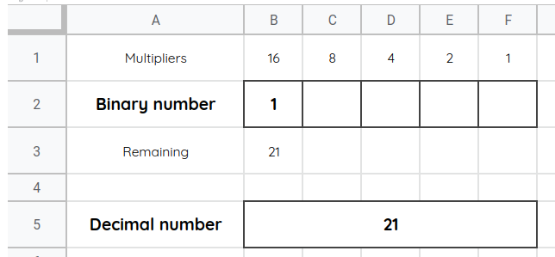

Step 5 The next remaining value
Compute the next remaining value.
If the previous binary digit was 0, then the remaining value is left unchanged (from the cell to the left). Otherwise, the new remaining value is the previous remaining value minus the previous multiplier.
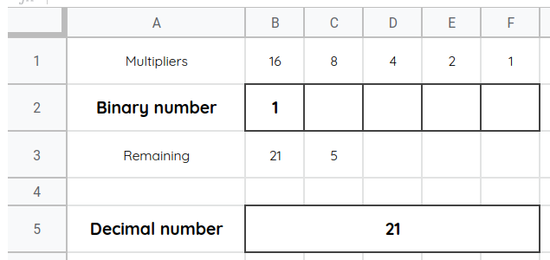

Step 6 The (rest of) the binary number
Use AutoFill to compute the rest of the binary digits and remaining values.
