Spreadsheet: binary to decimal
Follow these steps to create a spreadsheet that converts binary numbers into decimal.
You need to be familiar with simple formulas (calculating the product of two values), basic functions (calculating the sum of a range of cells), and the AutoFill feature.

Step 1 The binary number.
Designate an area (a group of cells) where the digits of the binary number will be entered.
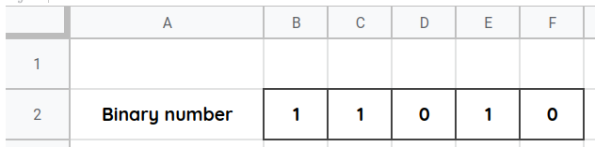

Step 2 Multipliers
Compute the multiplier for each of the binary digits. Use the cells above the binary digits.
Note: Do not enter the multipliers by hand, except the multiplier of the rightmost digit (which equals 1). Every other multiplier should be twice as big as the one to its right.
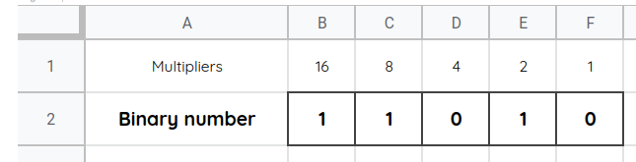

Step 3 Products
Compute the product of each binary digit and its corresponding multiplier. Use the cells below the binary digits.
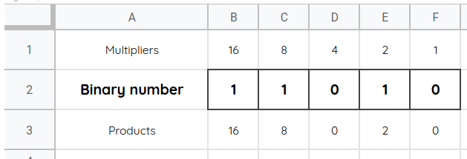

Step 4 The decimal number
Compute the decimal number. It is the sum of the products that you computed previously.
