Homework

Background information
How are binary digits stored and processed in digital devices?

Electronic components
Examples: processors (CPU, GPU), main memory (RAM), some storage devices (flash drives, SD cards, solid state disks).  In electronic components, 0s and 1s are represented by the flow of electricity, controlled by interconnected switches. | 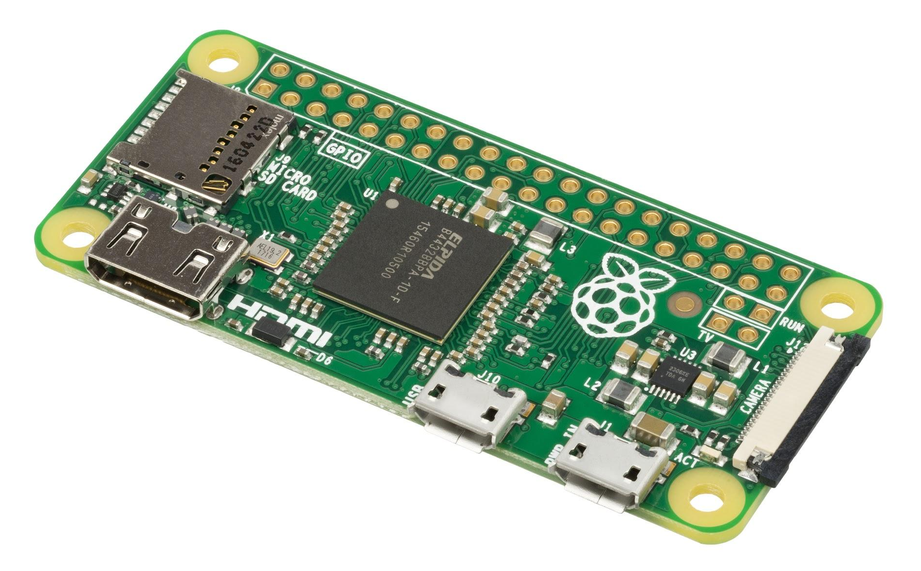

The past

Perforated paper
Perforated paper (in long strips or cards) was used for storing programs and data.
0s and 1s were represented by the presence or lack of holes in paper.
Magnetic core memory  The cores were metal rings, connected with wires. Each ring (core) stored one bit. Electricity was used for writing and reading the information in the cores.  0s and 1s were represented by the way in which each core was magnetised. | 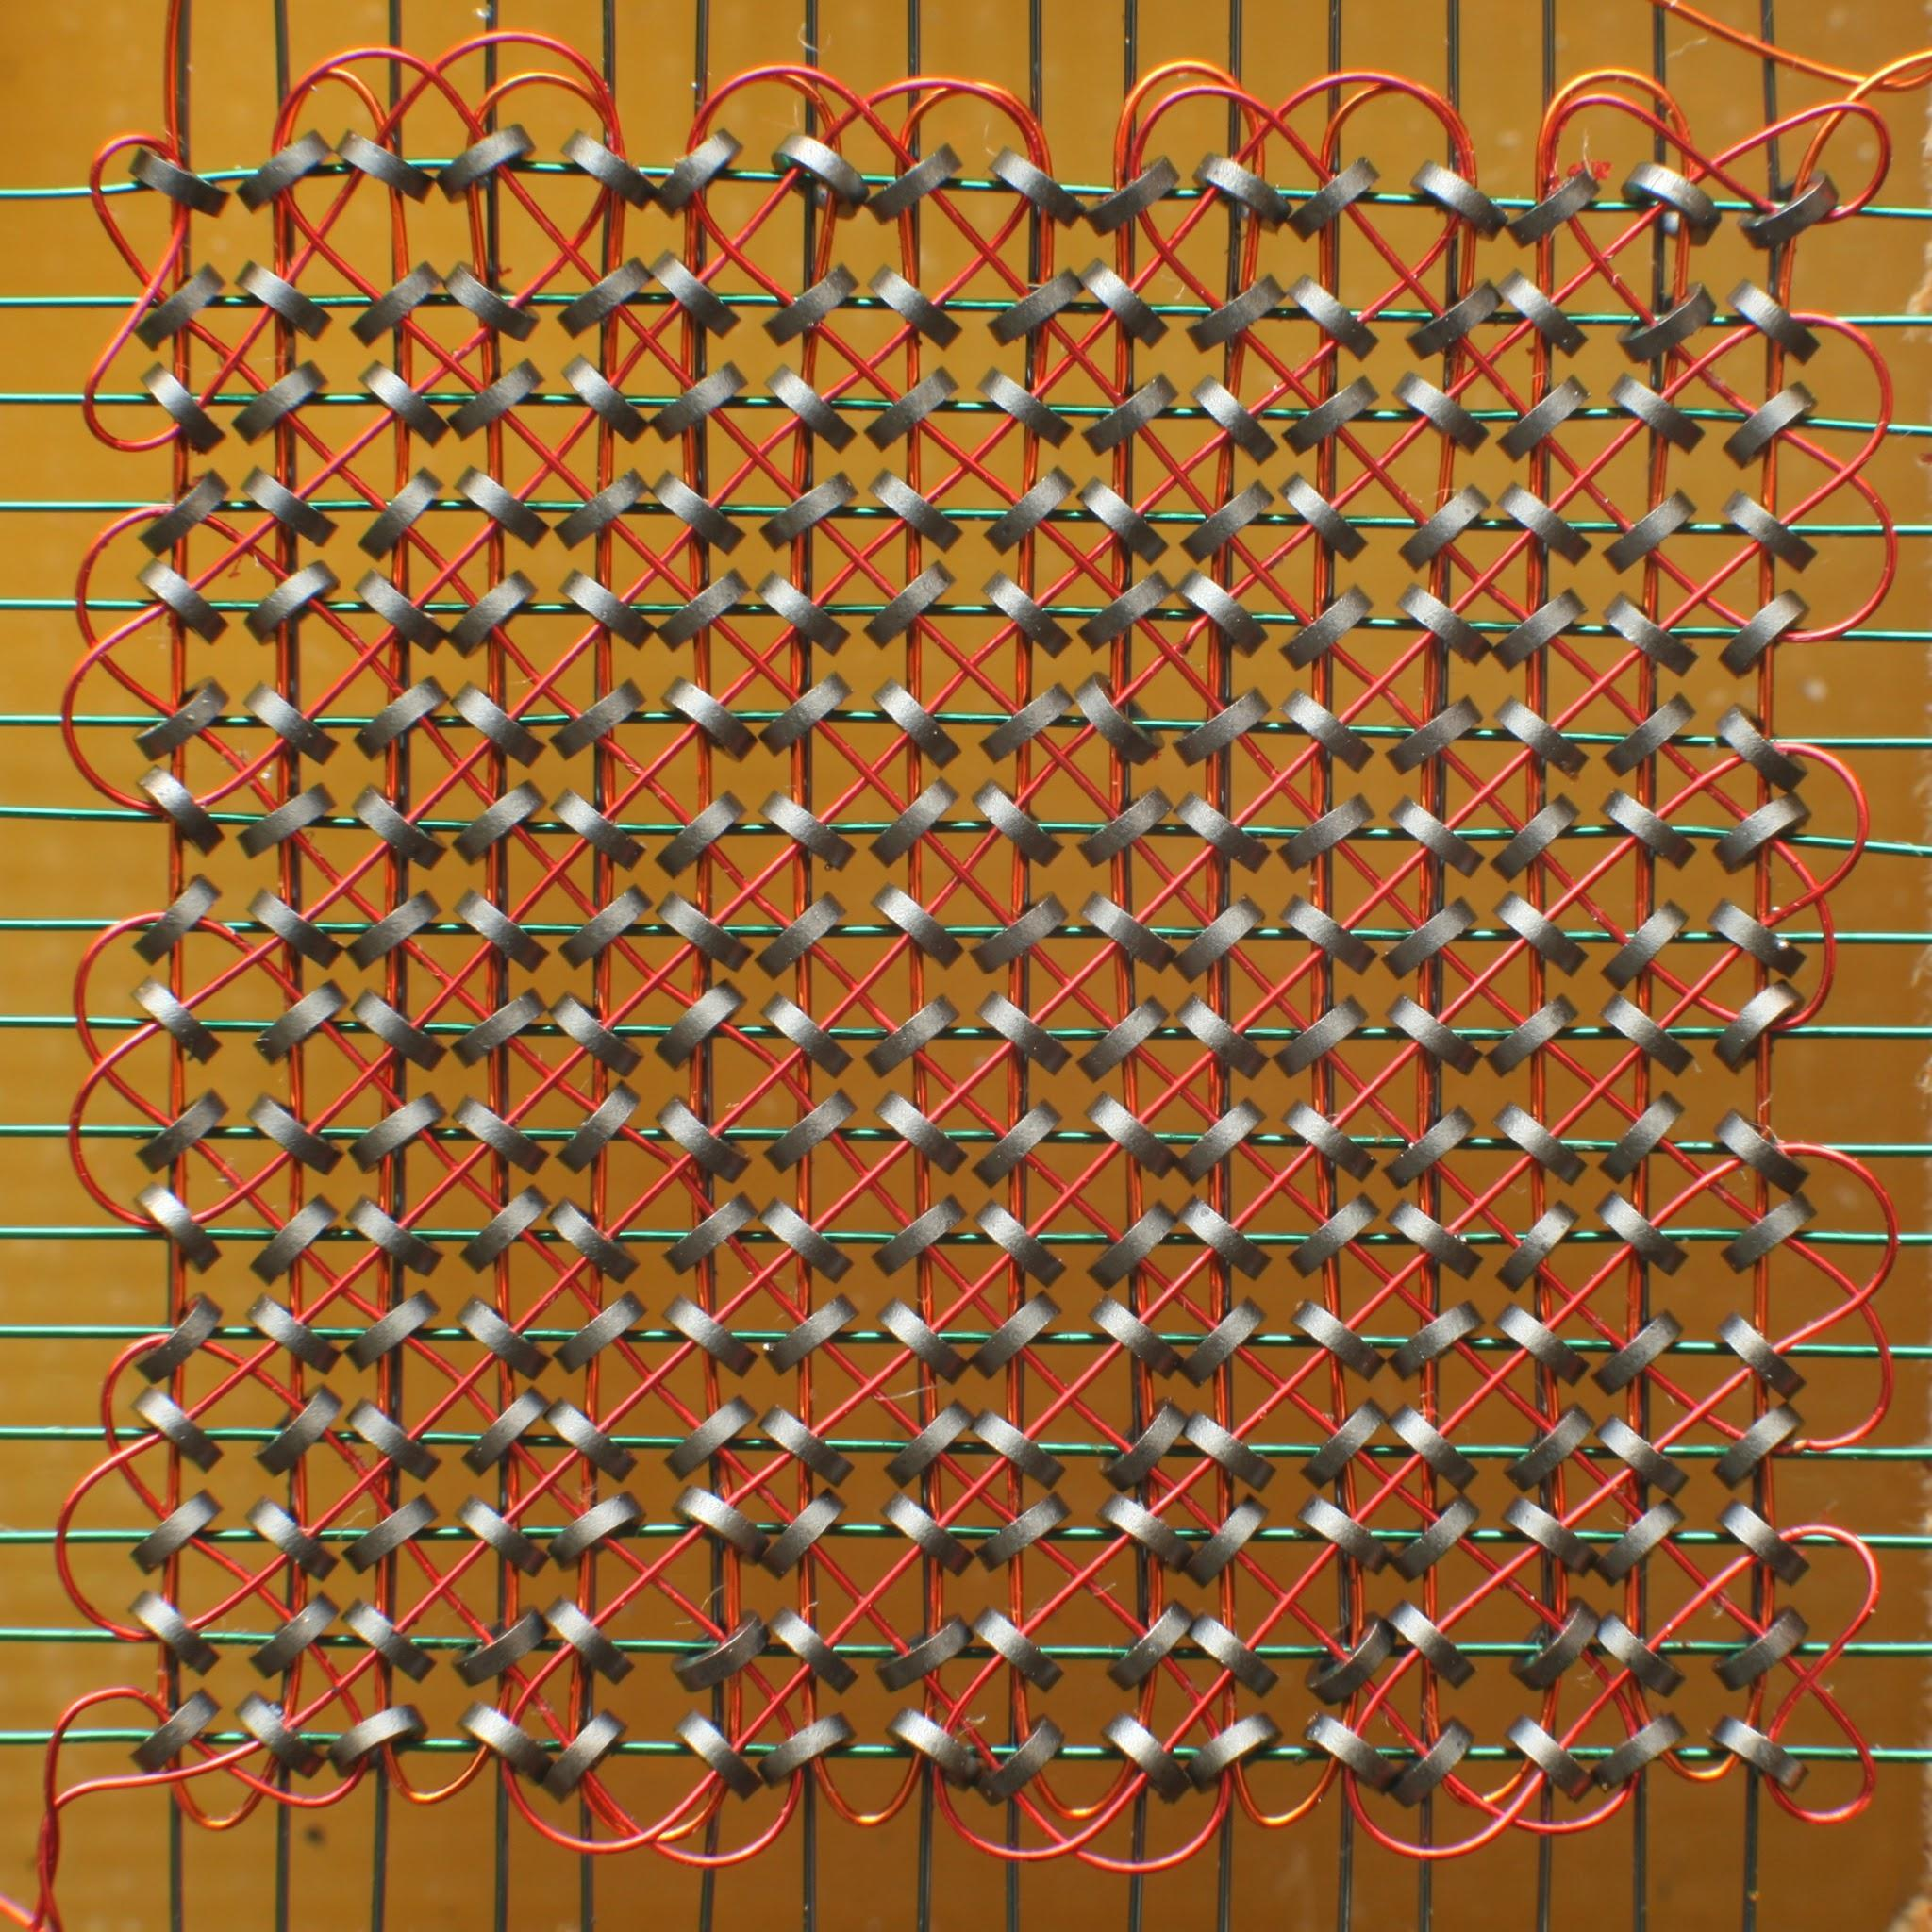

Hard disks | Hard disk: 1TB = 8 trillion binary digits
The material on the surface of hard disks is magnetic. 0s and 1s are represented as changes in the magnetic orientation (N-S or S-N) of individual regions on the surface.  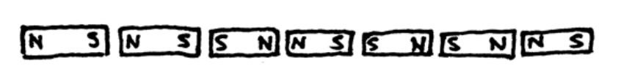 | 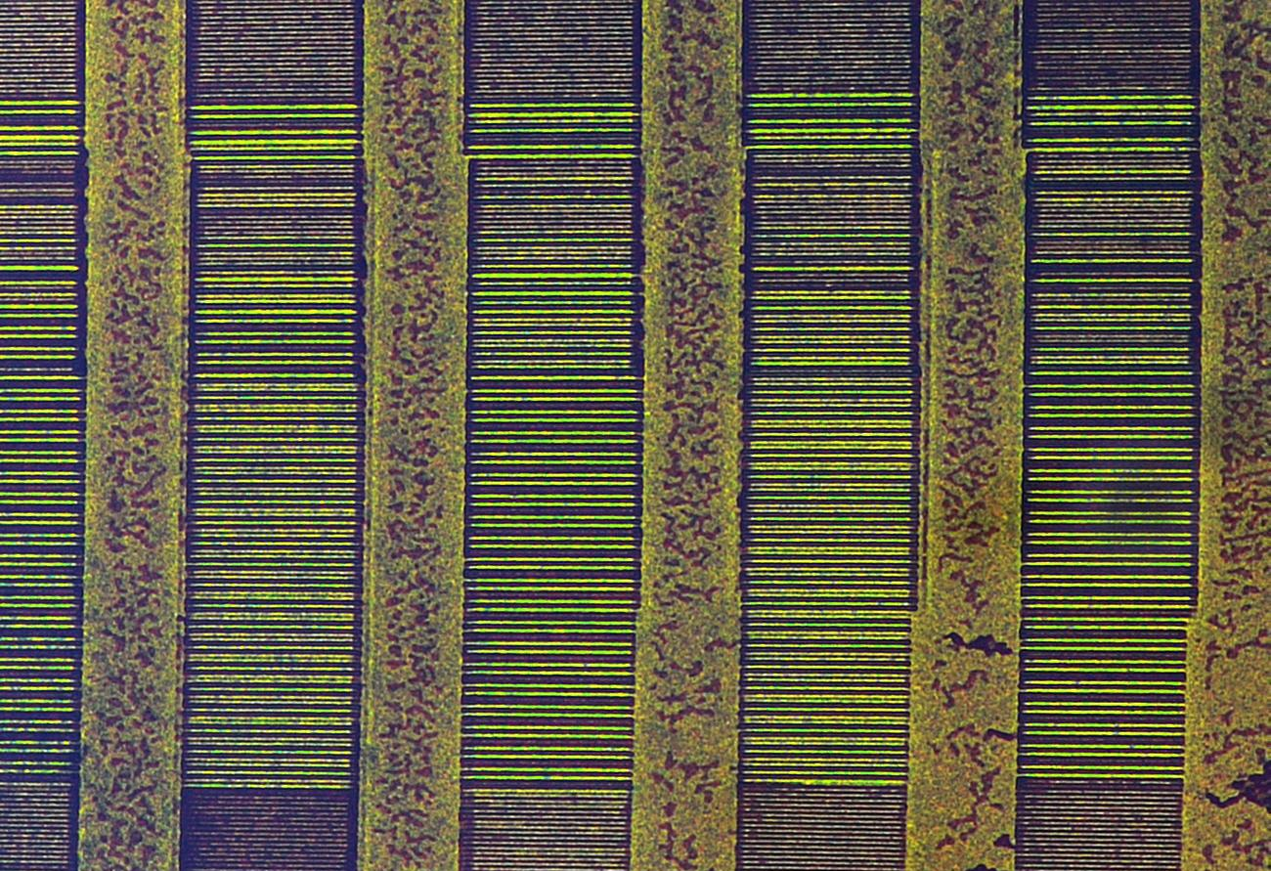
Optical disks | CD: 700MB = 5.6 billion binary digits
Examples: CDs, DVDs, and Blu-ray Discs.  The surface of optical disks is reflective. 0s and 1s are represented by pits (microscopic holes) or lands (regions without holes).  Light is used to read the binary digits off the surface of the disk.  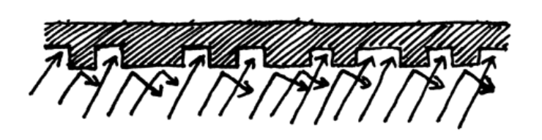 | 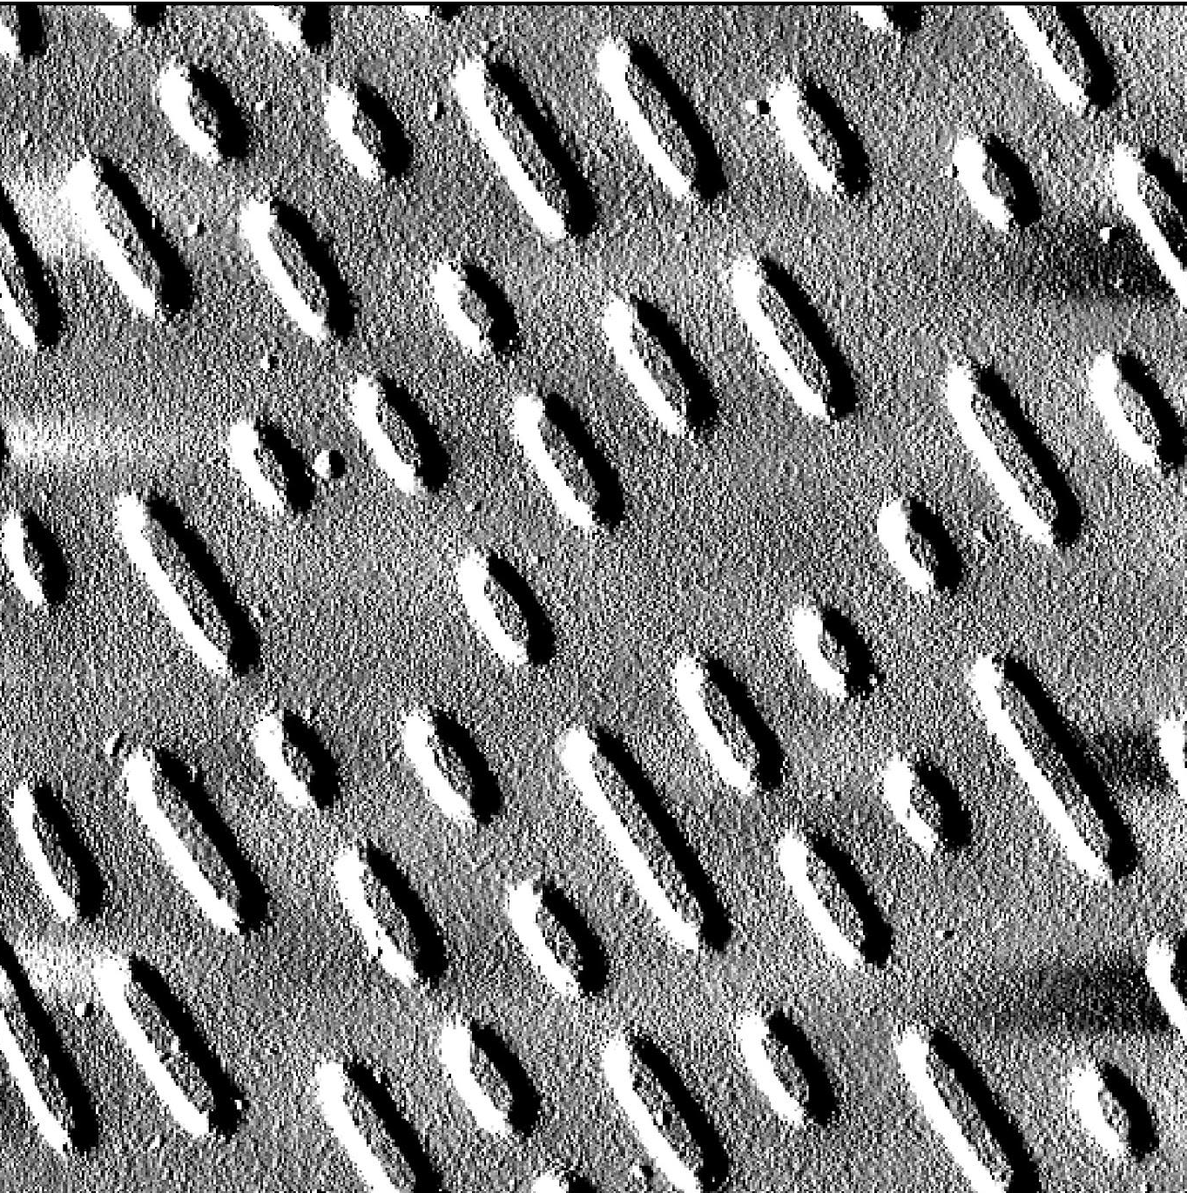

How are binary digits transmitted between digital devices?
Wired connections  Binary digits are transferred through wires using electricity.  Binary digits are transferred through fibre-optic cables using light. | 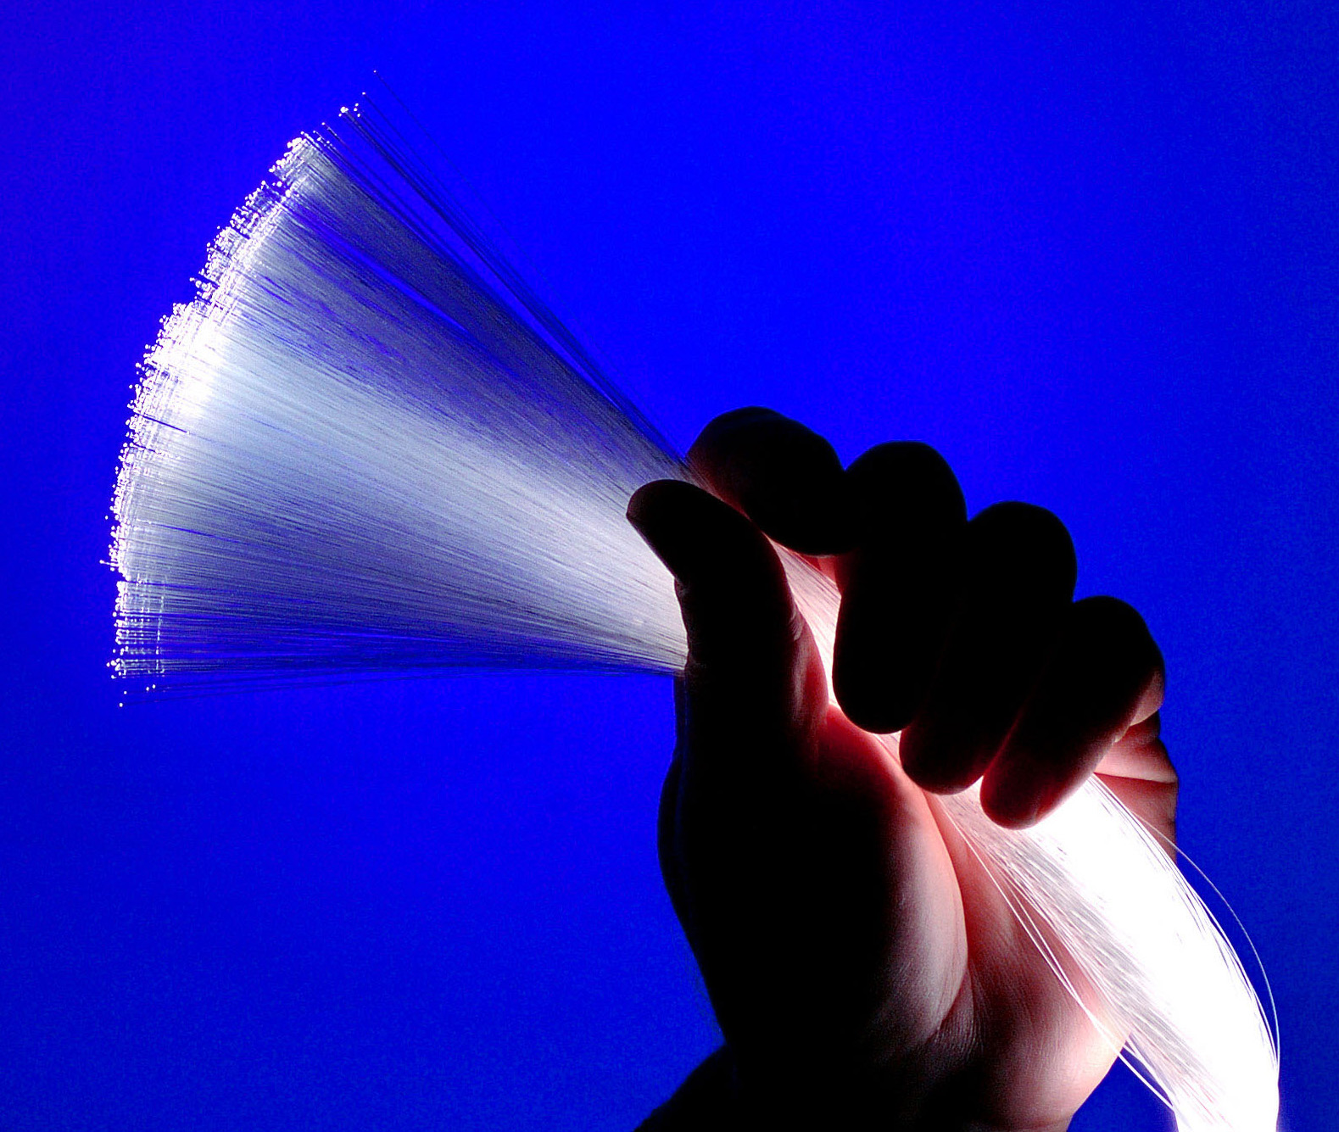
Wireless connections  In all wireless communications, binary digits are transferred using electromagnetic waves, transmitted and received by antennae. | 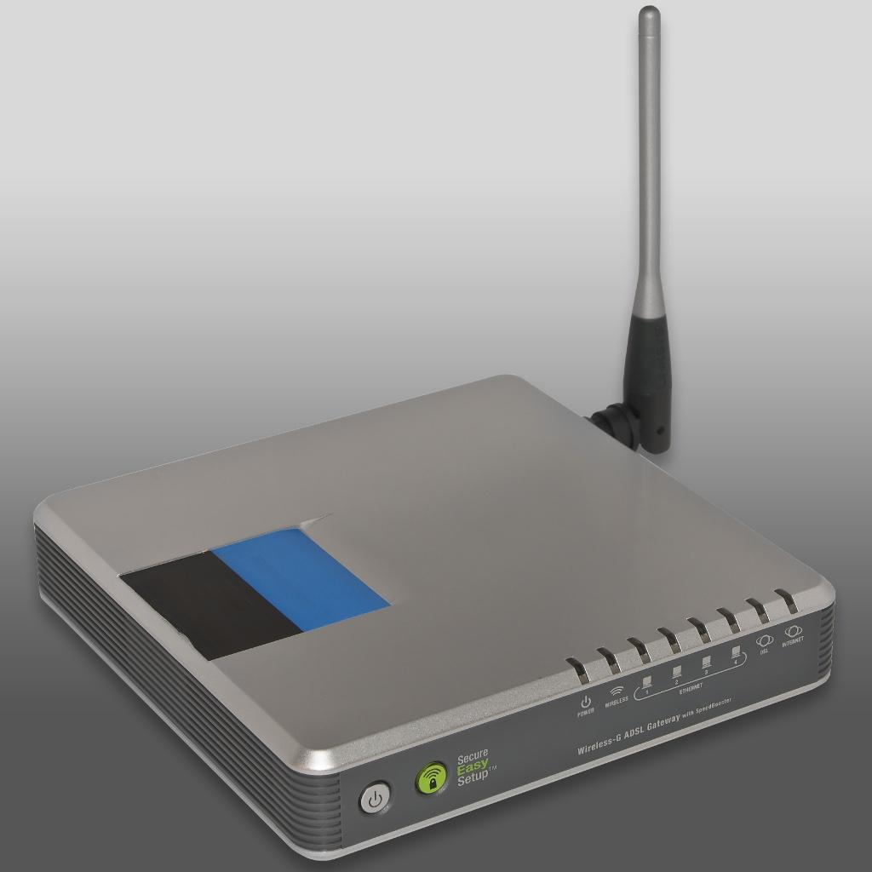

Study the background information provided on these pages and answer the questions on the Microsoft Form on Bourne to Code.
If required, you could investigate further, searching for relevant resources on the internet.

